**DAILY ONLINE ACTIVITIES SUMMARY**

|  |  |  |  |  |  |  |  |  |
| --- | --- | --- | --- | --- | --- | --- | --- | --- |
| **Date:** | **29-05-2020** | | | | | **Name:** | **Shiza Amreen.J** | |
| **Sem & Sec** | **4th sem B sec** | | | | | **USN:** | **4AL18CS078** | |
| **Online Test Summary** | | | | | | | | |
| **Subject** | | **Operating System** | | | | | | |
| **Max. Marks** | | **30** | | **Score** | | | **28** | |
| **Certification Course Summary** | | | | | | | | |
| **Course** | **Python for Machine Learning** | | | | | | | |
| **Certificate Provider** | | | **GreatLearning** | | **Duration** | | | **5 Hours** |
| **Coding Challenges** | | | | | | | | |
| **Problem Statement:**   1. [**Write a C Program to generate first N Armstrong Numbers**](https://github.com/orgs/alvas-education-foundation/teams/2nd-year/discussions/87) 2. [**Write a Java program to Find size of the largest ‘+’ formed by all ones in a binary matrix**](https://github.com/orgs/alvas-education-foundation/teams/2nd-year/discussions/86) | | | | | | | | |
| **Status: Completed** | | | | | | | | |
| **Uploaded the report in Github** | | | | | **yes** | | | |
| **If yes Repository name** | | | | | **Lockdown_Coding** | | | |
| **Uploaded the report in slack** | | | | | **yes** | | | |

Online Test Details:

Today I had Operating System IA-2, I have attended the test and got 28 out of 30 and submitted it.

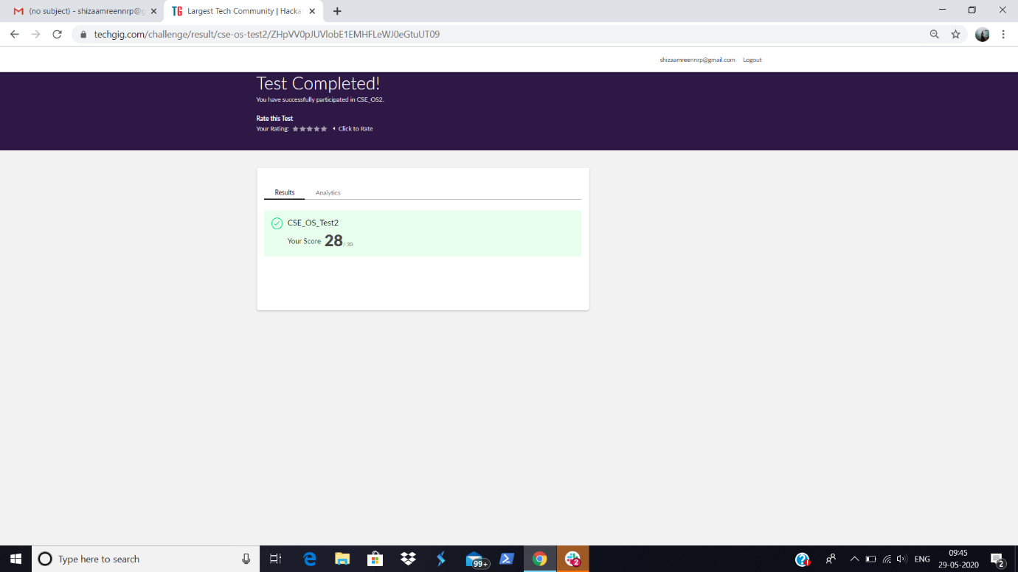

Certification Course Details:

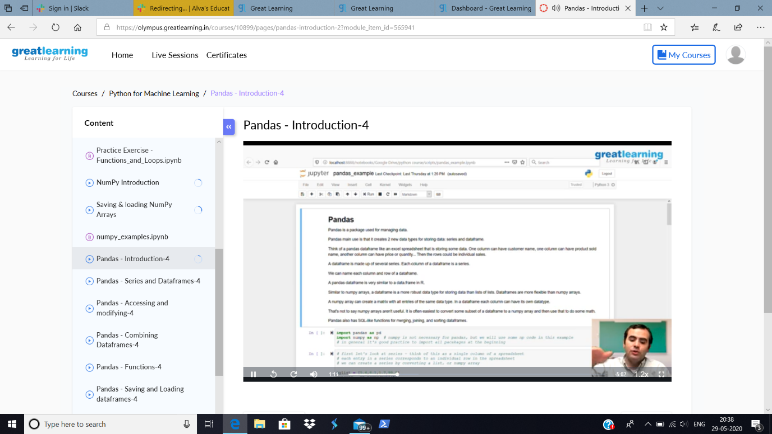

Today I have gone through the concepts of Pandas Introduction in Python for Machine Learning.

Later, As suggested by my Faculty Advisor, Mrs. Vidya mam, I have taken Online Quiz on Data & Communication Network.

I scored 85 out of 100 and got the Certificate.

<https://docs.google.com/forms/d/e/1FAIpQLSczDG3VLdVLw_CdHjbjqJXnaRpi92D10Dad7JSP44-NTEaJoQ/viewform>

<https://mail.google.com/mail/u/0?ui=2&ik=75e7b573e1&attid=0.1&permmsgid=msg-f:1668031791719860626&th=17260a13b3854992&view=att&disp=inline>

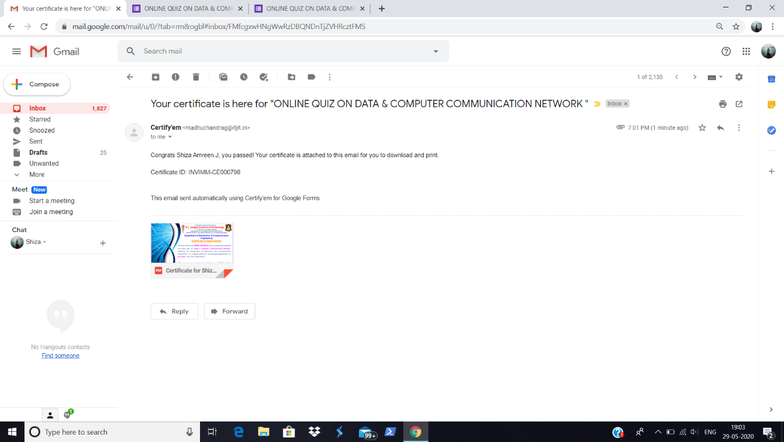

Certificate:

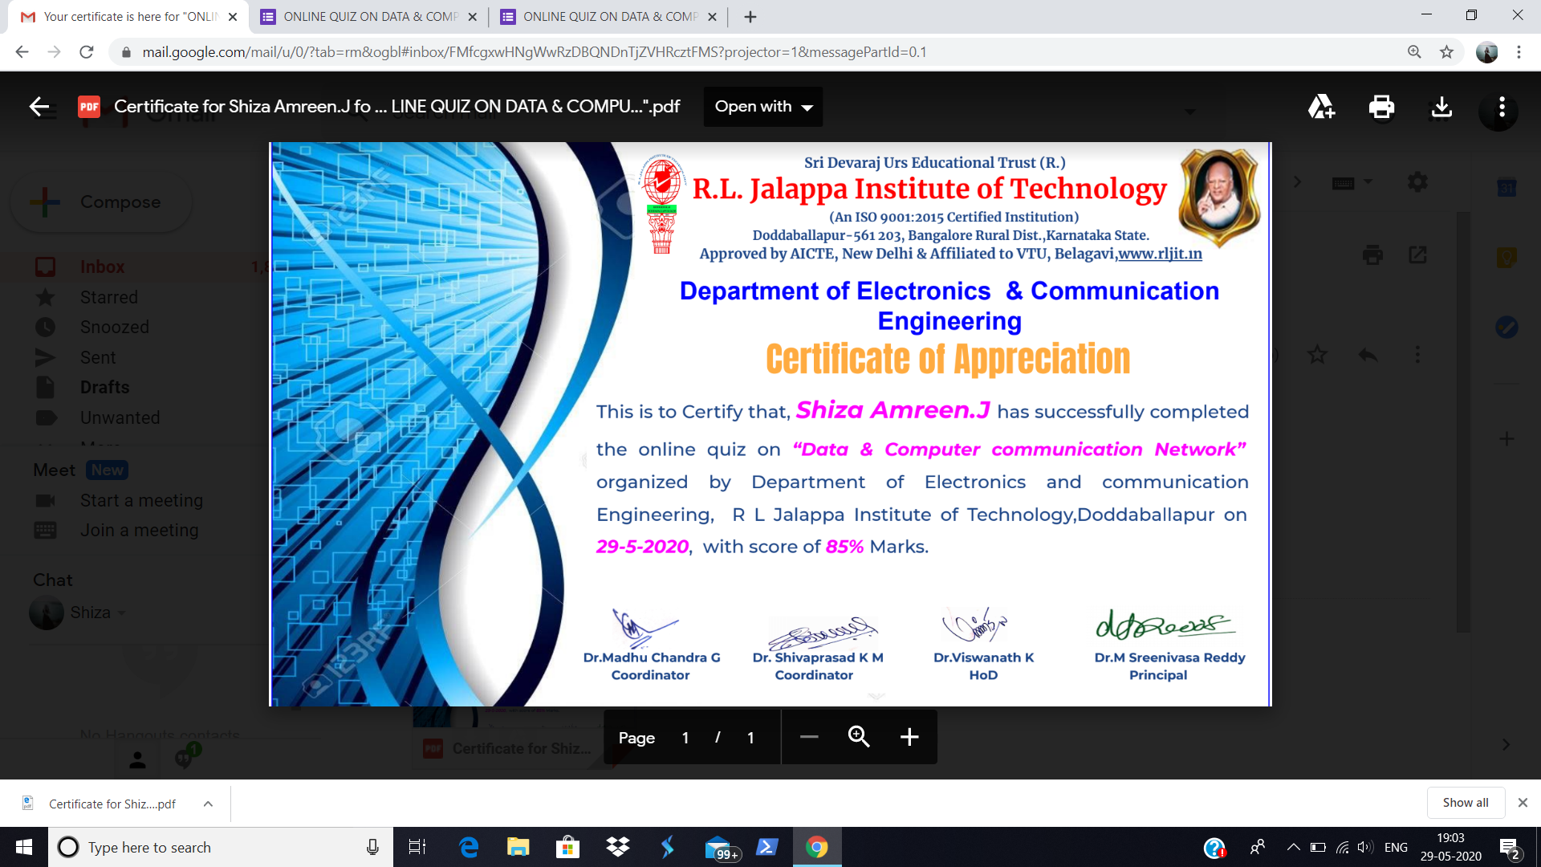

Coding Challenges Details:

|  |
| --- |
| **Problem Statement:**   1. [**Write a C Program to generate first N Armstrong Numbers**](https://github.com/orgs/alvas-education-foundation/teams/2nd-year/discussions/87) 2. [**Write a Java program to Find size of the largest ‘+’ formed by all ones in a binary matrix**](https://github.com/orgs/alvas-education-foundation/teams/2nd-year/discussions/86) |

**I have written the code for given problem statements and uploaded it in my github repository.**

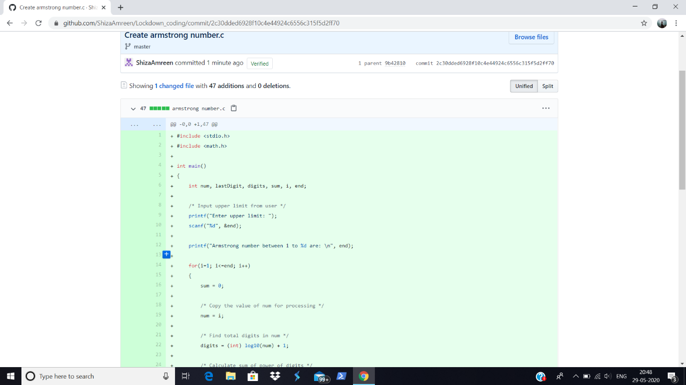

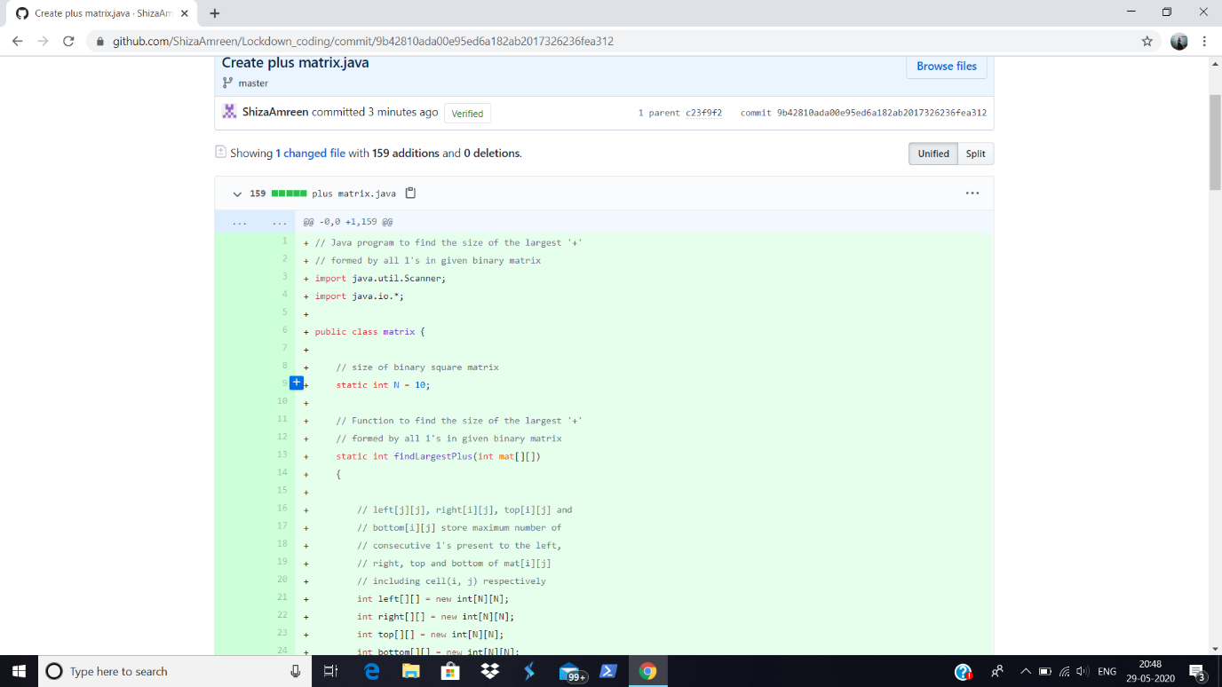

<https://github.com/ShizaAmreen/Lockdown_coding/commit/2c30dded6928f10c4e44924c6556c315f5d2ff70>

<https://github.com/ShizaAmreen/Lockdown_coding/commit/9b42810ada00e95ed6a182ab2017326236fea312>